Process management

System process:
user process:
process ID 1 = system d (RHEL 7,8,9,10)
Process ID 1 = init (before RHEL 7)
PID = process ID
PPID = parent process ID
systemd start firstly when computer start and stop at last when computer is shutdown.
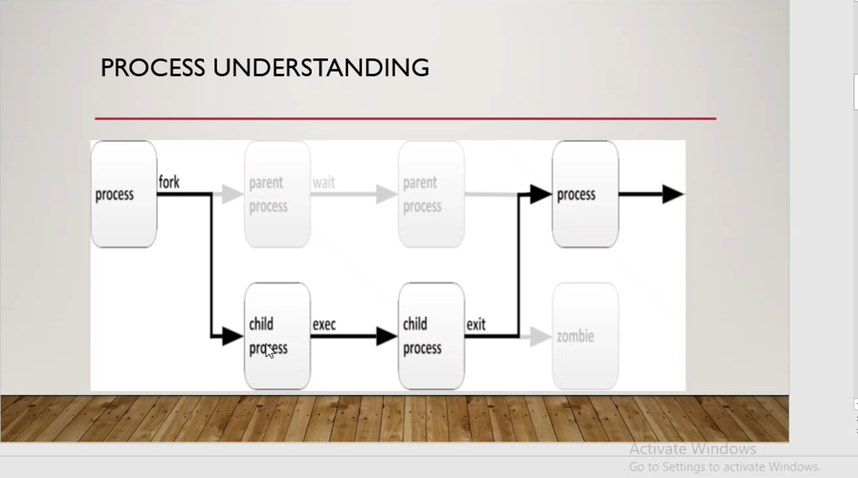
Process states:
running: the process is running
sleeping: the process is in waiting for other like we run yum update and without complete yum update we run yum install then it should be in sleeping state
stopped: the process is stopped
zombie: when any child process is work done but not releasing PID and resources this process called zombie process.

